**MS SQL 2016 TRANSACTIONAL REPLICATION SETUP**

**PREPARATION**

**Two Instance with two servers.**

**MSSERVER-1\MSSQLSERVER1**

**MSSERVER-2\MSSQLSERVER2**

# CONFIGURE DISTRIBUTION

* 1. **In MSSERVER-1\MSQLSERVER1 SQL Server Agent must be run or started**

Right click on Sql Server Agent and click Run.

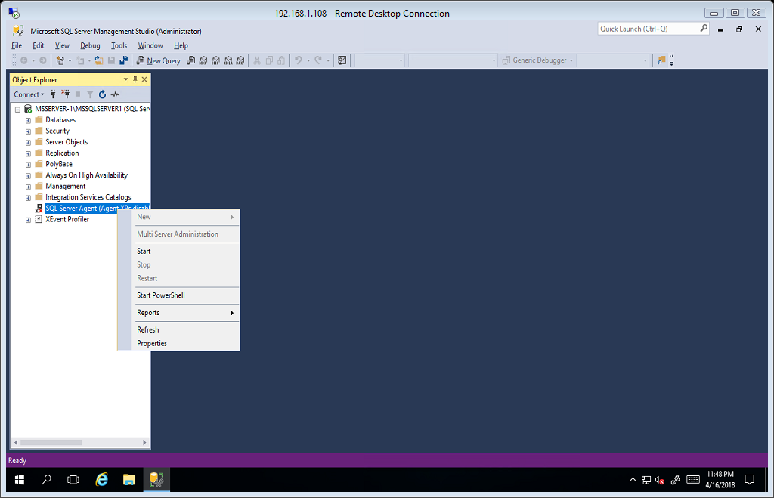

Click Yes to start the service

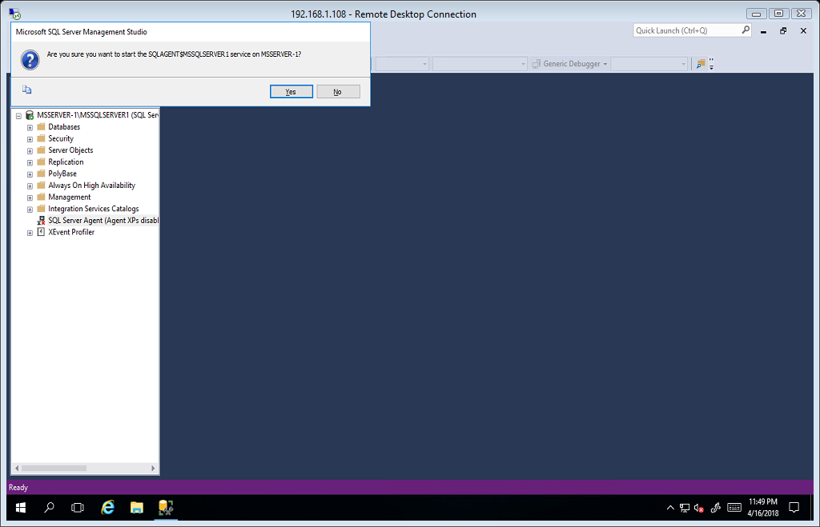

Sql Server Agent are now running.

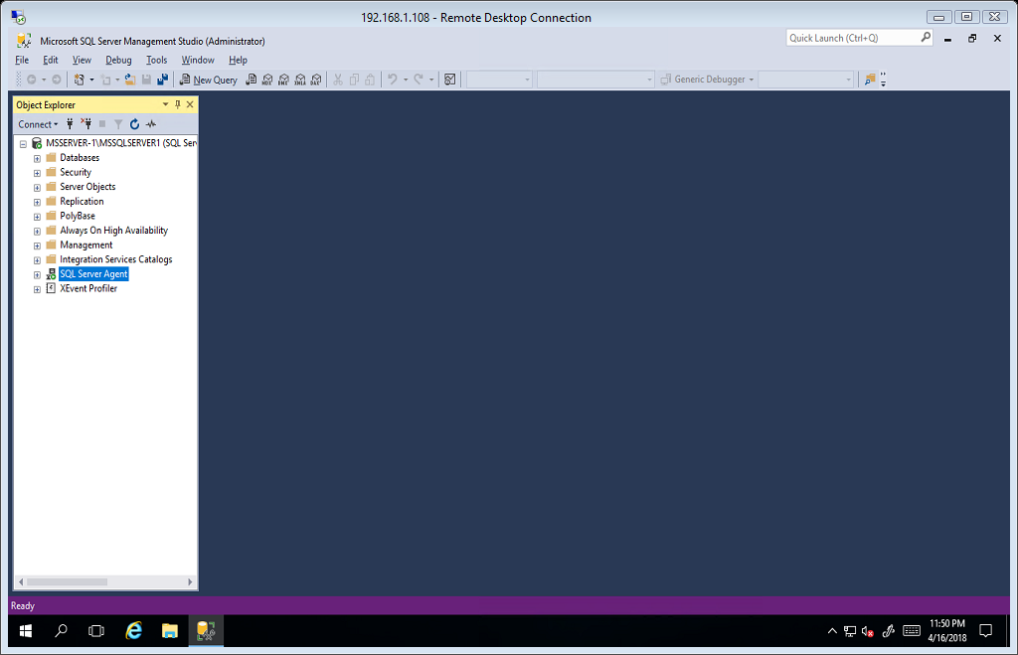

Right click on the replication folder and click **Configure Distribution**.

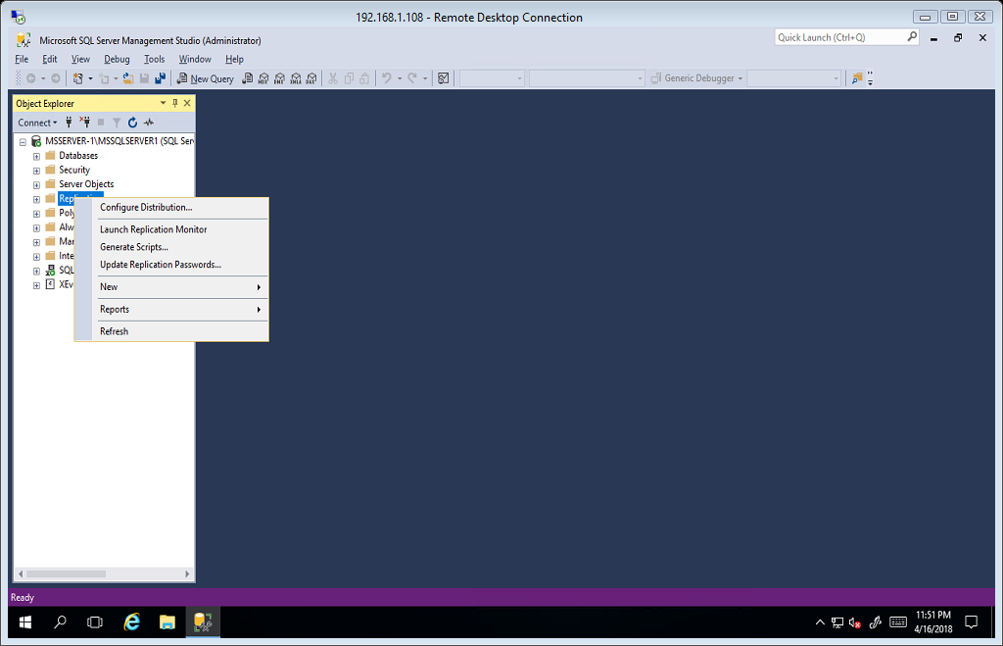

Configuration Distribution Wizard. Click Next to proceed.

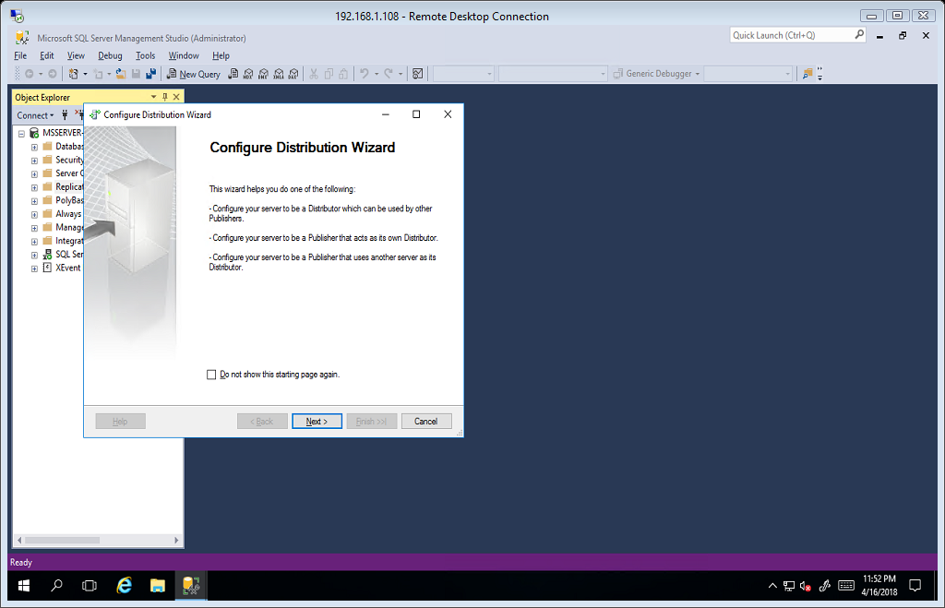

Select Server for Distribution, select first option if the default server distribution will be use. Click next.

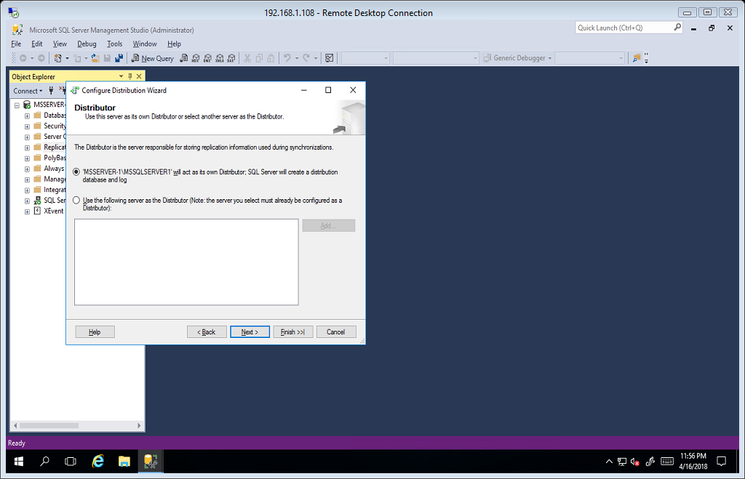

Select Yes, configure the SQL Server Agent service to start automatically. Click next.

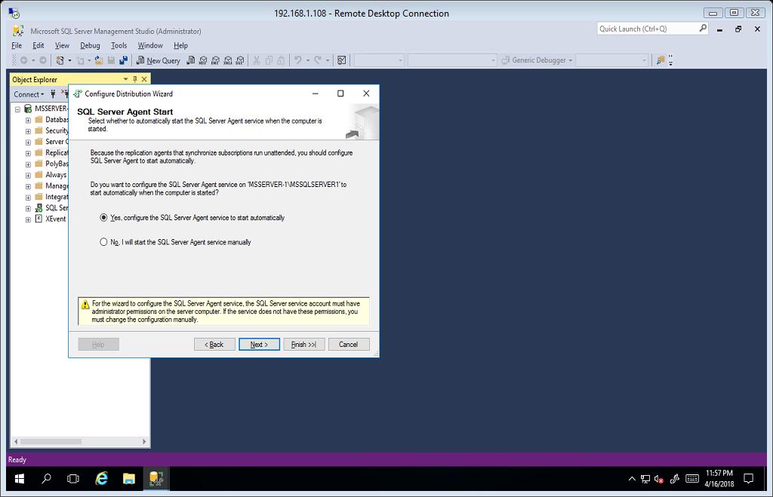

Snapshot Folder(Default). Click next.

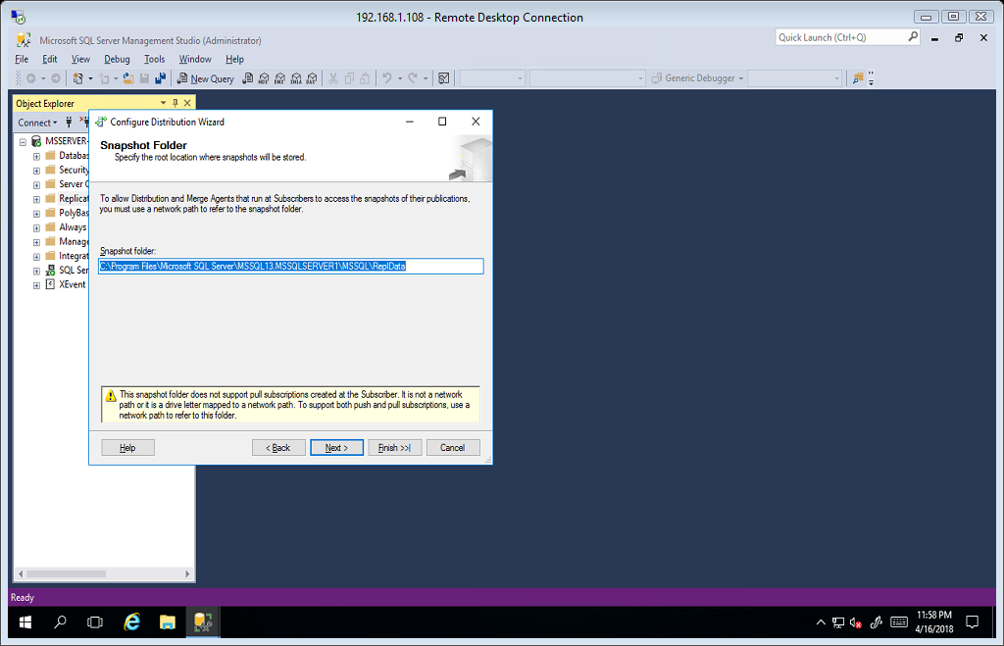

Distribution Database Information(default). Click next.

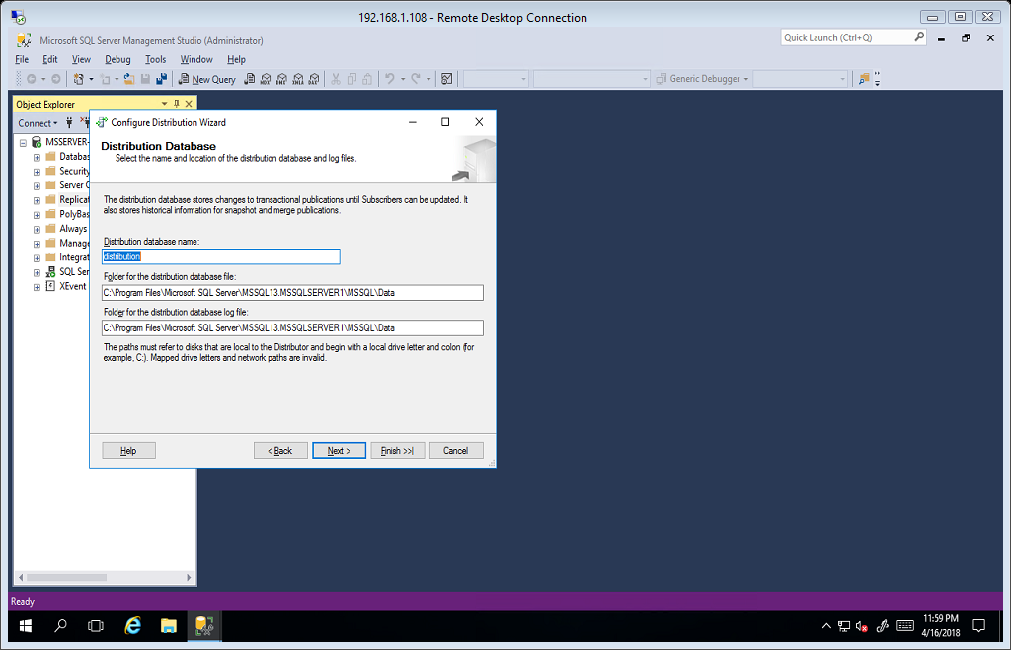

Publishers, Enable servers to use this Distributor when they become Publishers. In this scenario our publisher is MSSERVER-1\MSSQLSERVER1. Click next.

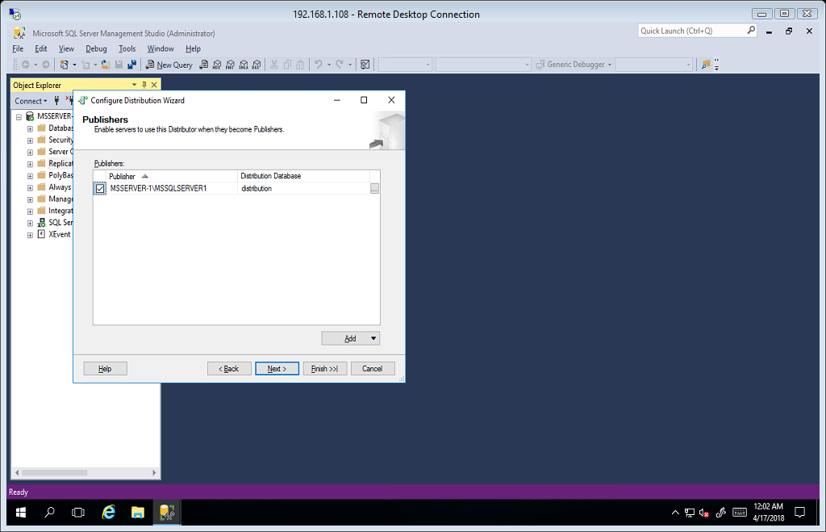

Select Configure distribution and click next.

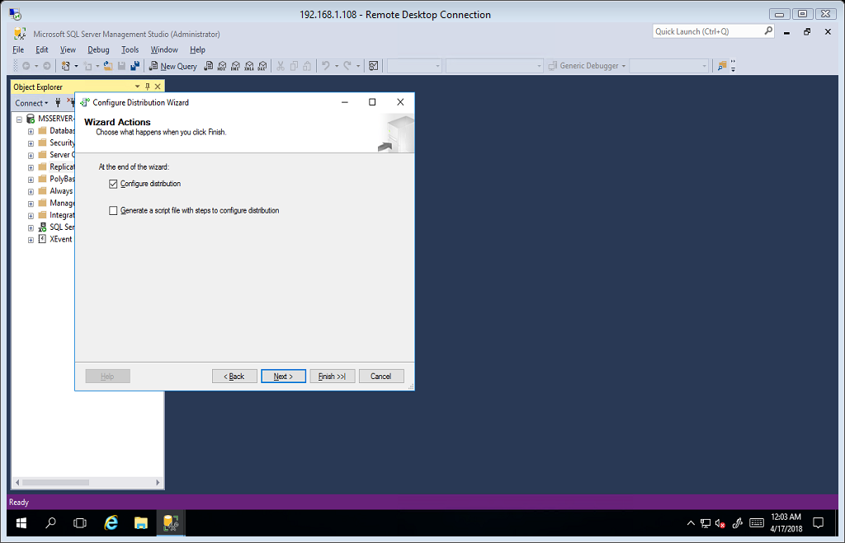

Click finish to complete the wizard.

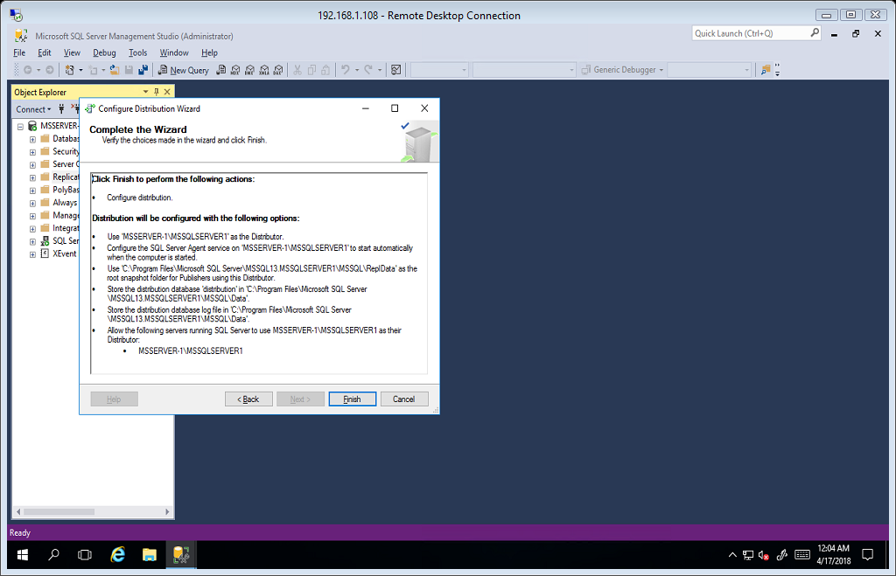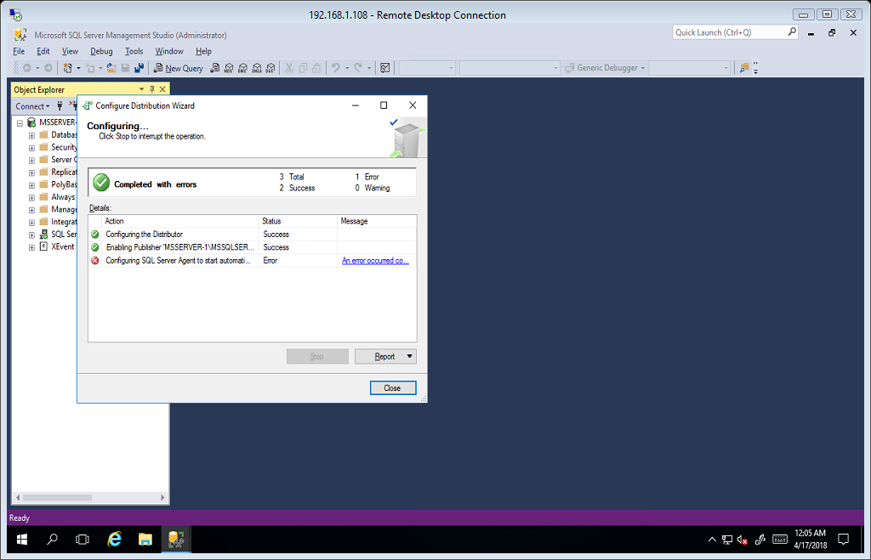

# PUBLISHERS

Our Publisher server is MSSERVER-1\MSSQLSERVER1

Expand the replication folder and right click on Local Publication folder, then select new publication.

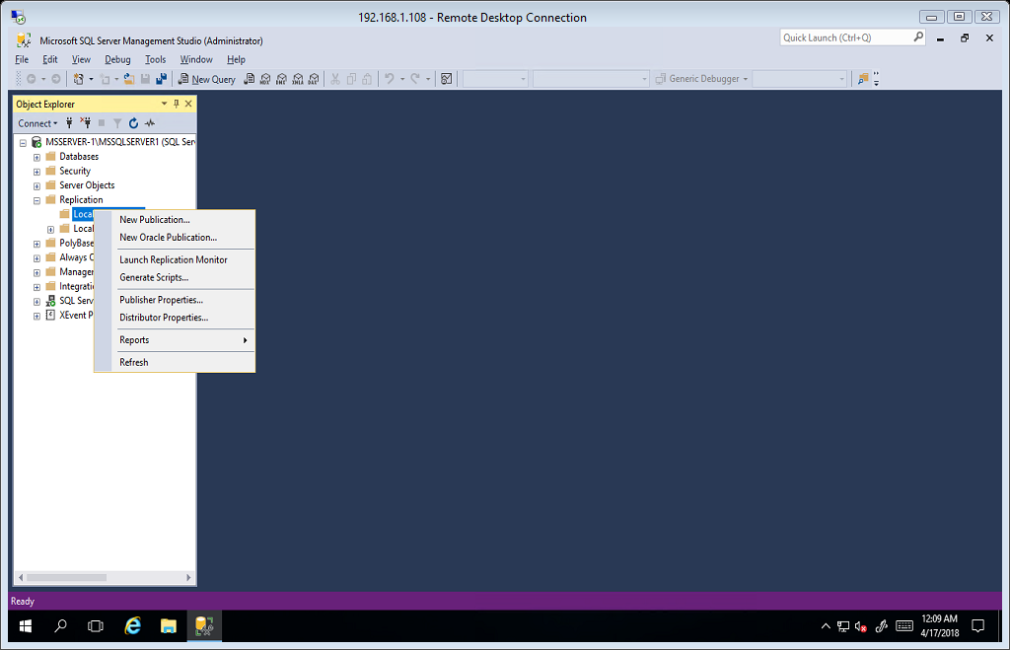

New Publication Wizard. Click next.

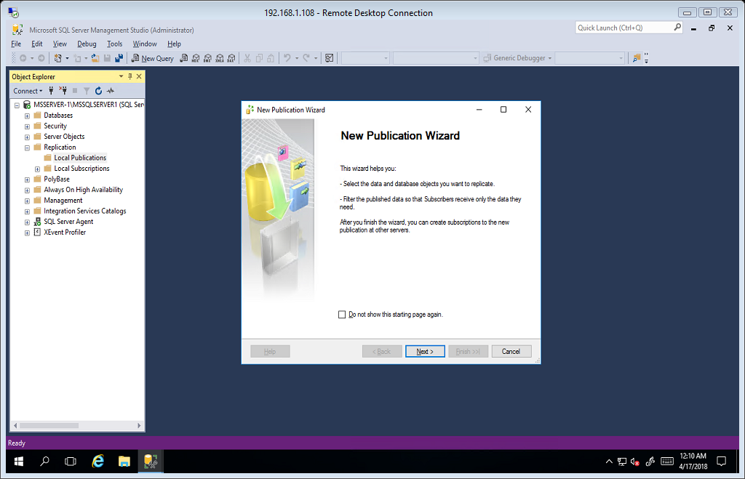

Select Publication Database, in this scenario we select test database. Click next.

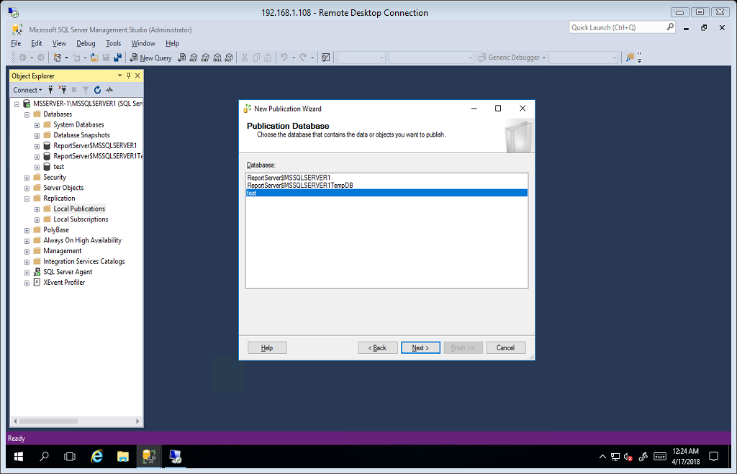

Publication Type. In this scenario we select Transactional Publication. Click next.

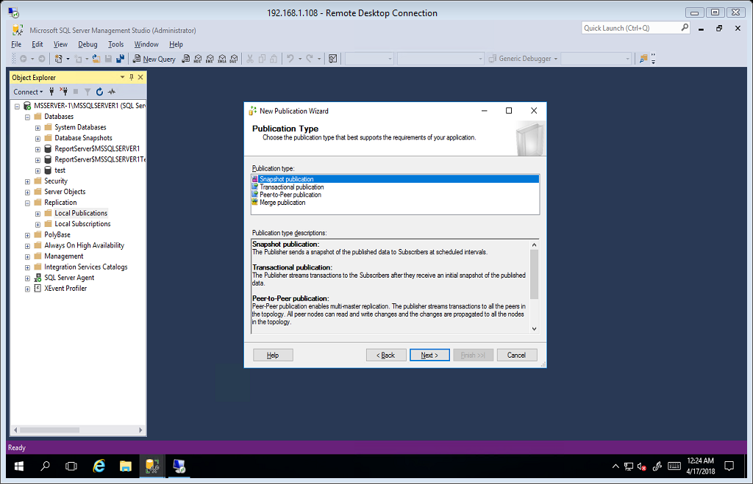

Articles, Select table, view, stored procedure or function that you want to replicate. In this scenario we select several tables. And click next.

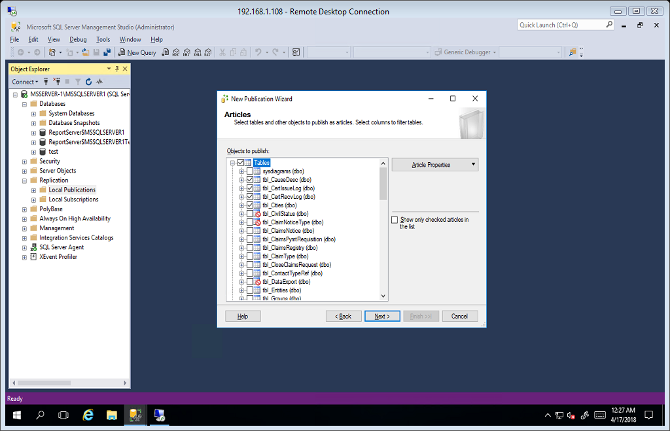

Filter Table Rows. You can add filter by clicking add but for this scenario just click next.

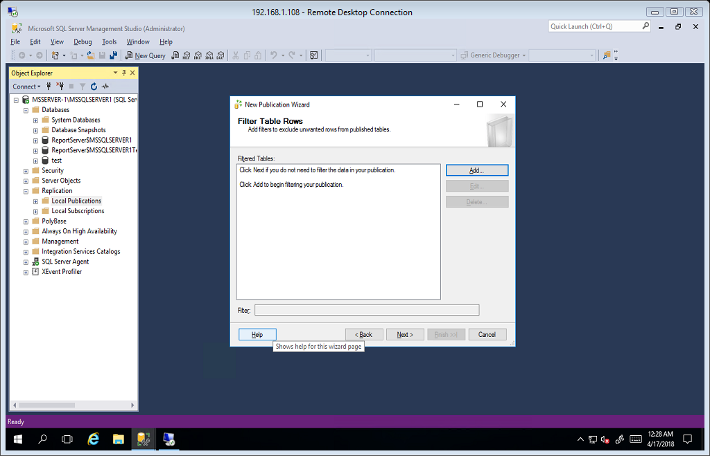

Snapshot Agent, Select create a snapshot immediately and keep the snapshot available to initialize subscriptions.

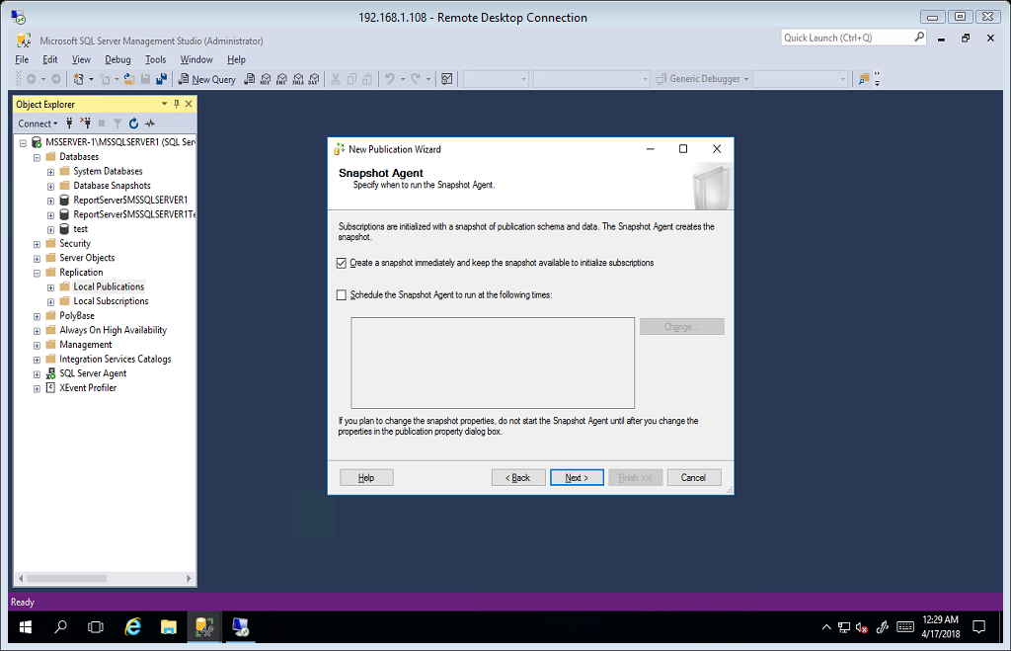

Agent Security. In snapshot agent select Security Settings.

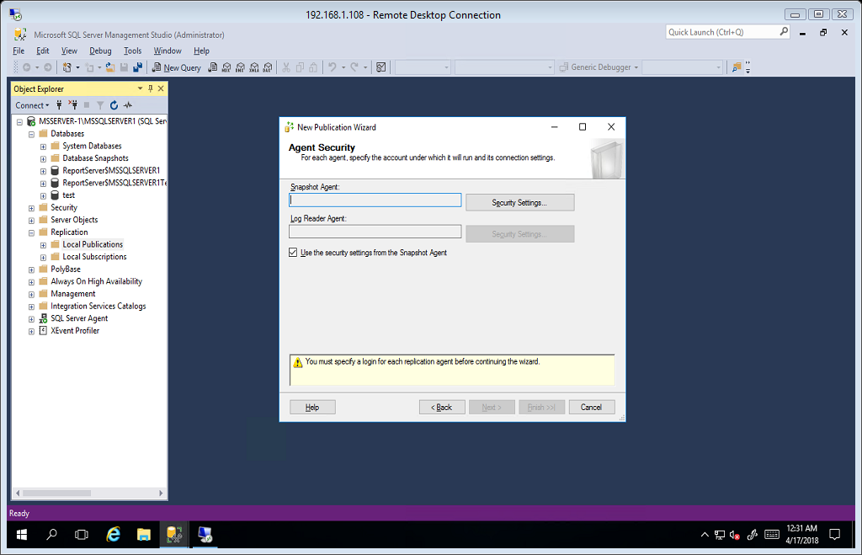

Select option run agent the SQL Server Agent service account(recommended).

Connect to the Publisher, Select option using the following Sql Server login. Enter sa credentials. Click ok.

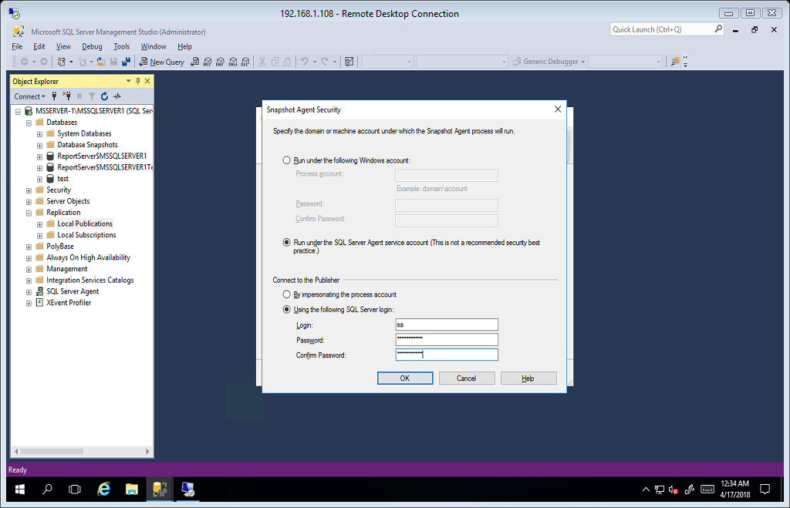

Click next to proceed.

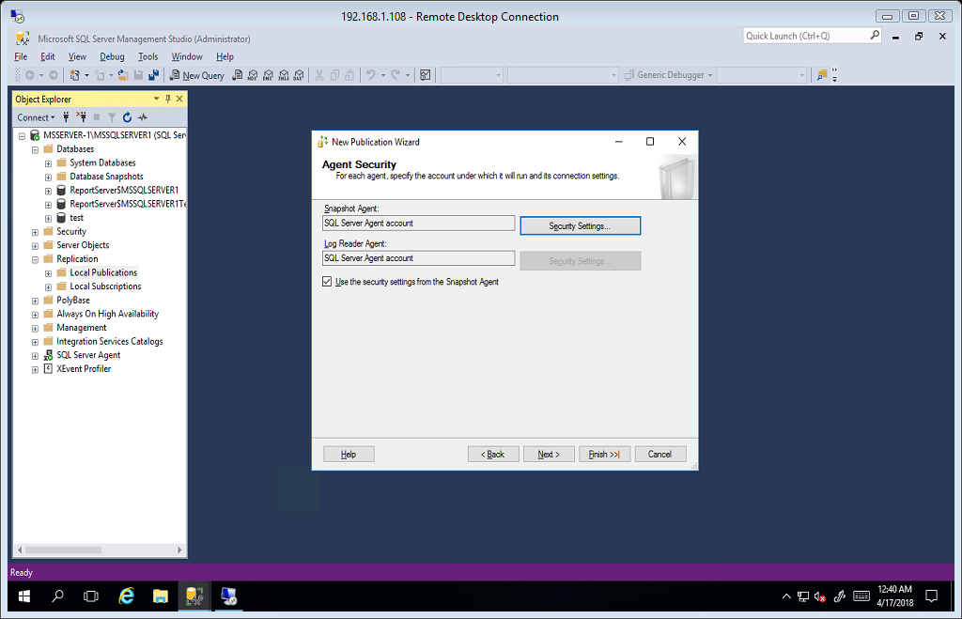

Select create the publication and click next.

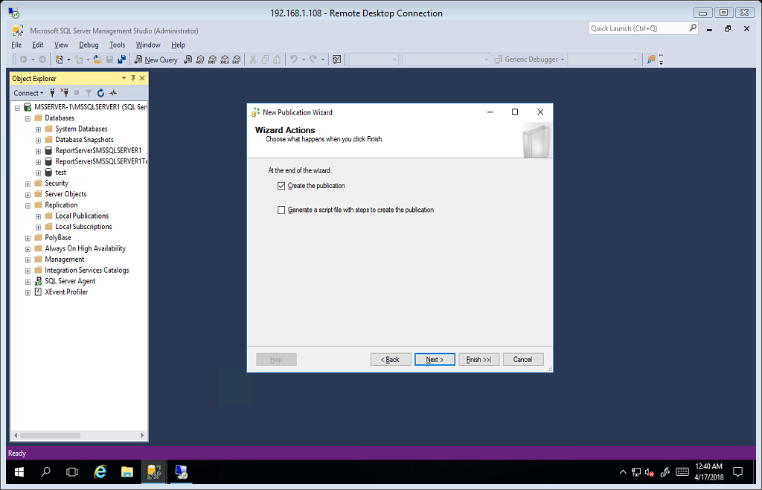

Enter Publication Name, for this scenario we use PUB1 for publication name. Click finish.

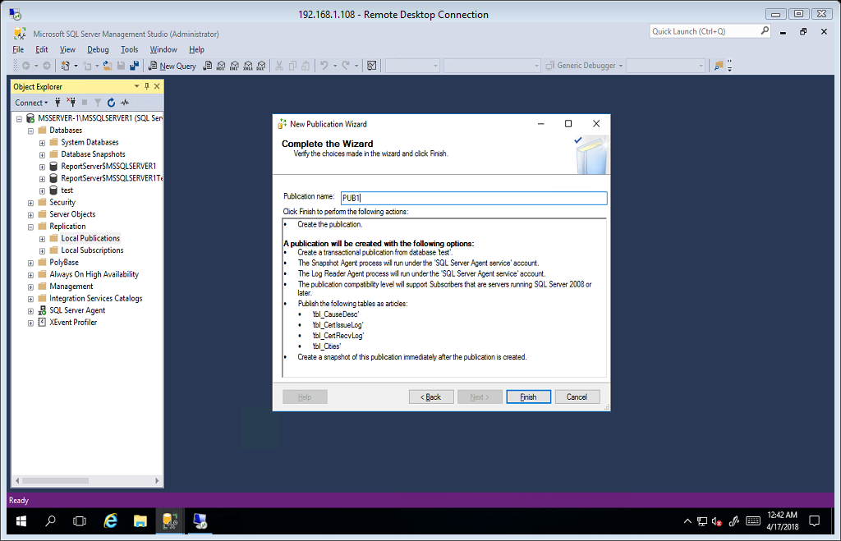

Click Close.

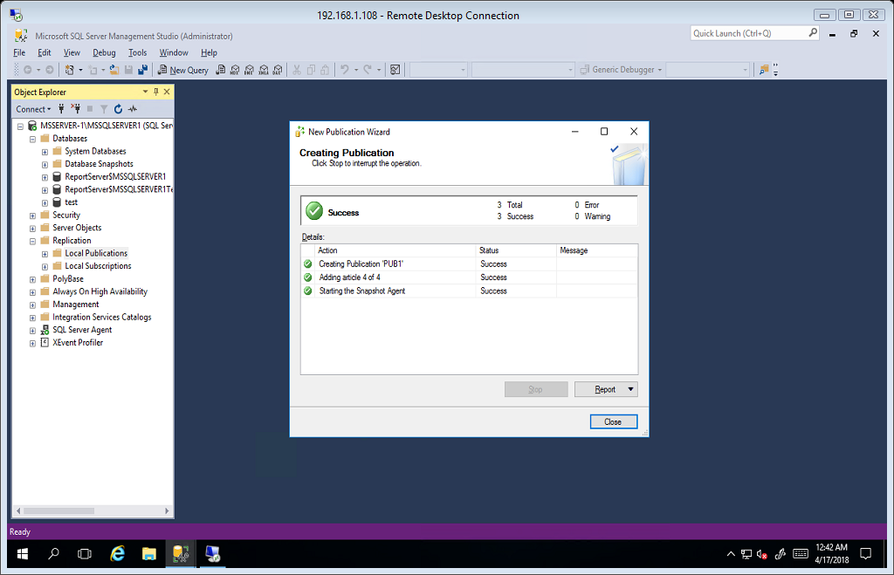

# SUBSCRIBER

For this scenario we will use MSSERVER-2\MSSQLSERVER2 as our subscriber server.

Expand replication folder and right click on local subscriptions and click New Subscriptions.

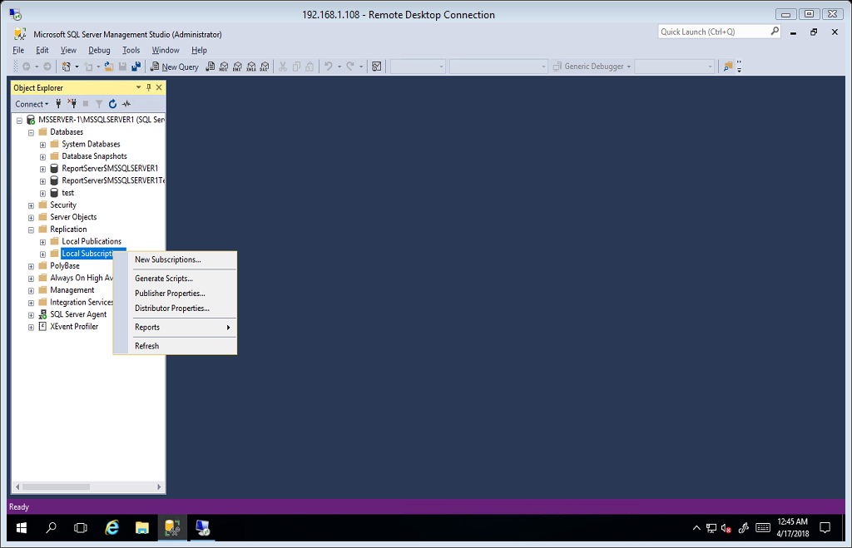

Subscription Wizard. Click next.

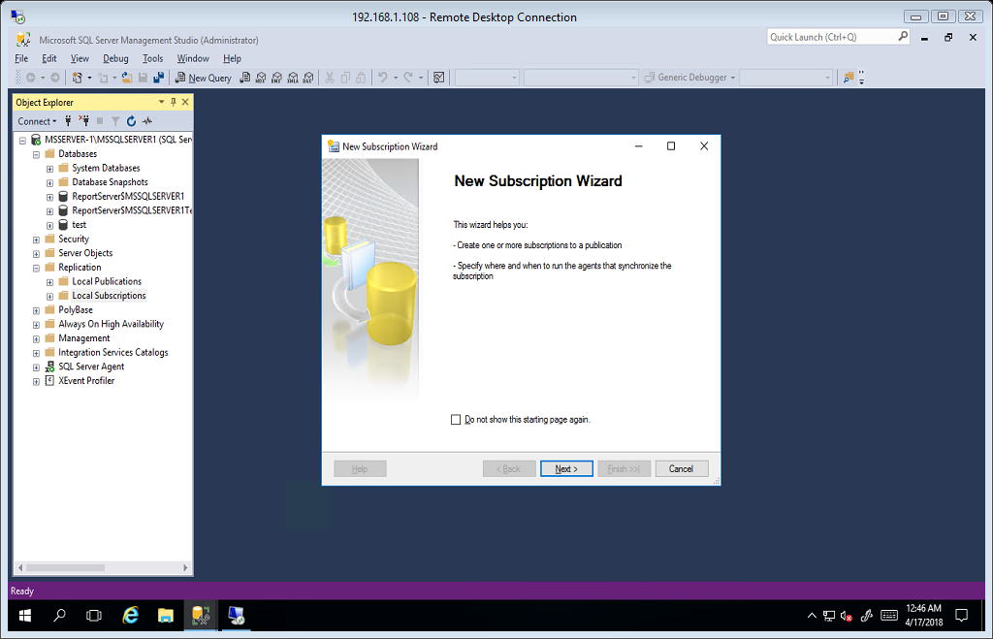

Select Publisher. Click next.

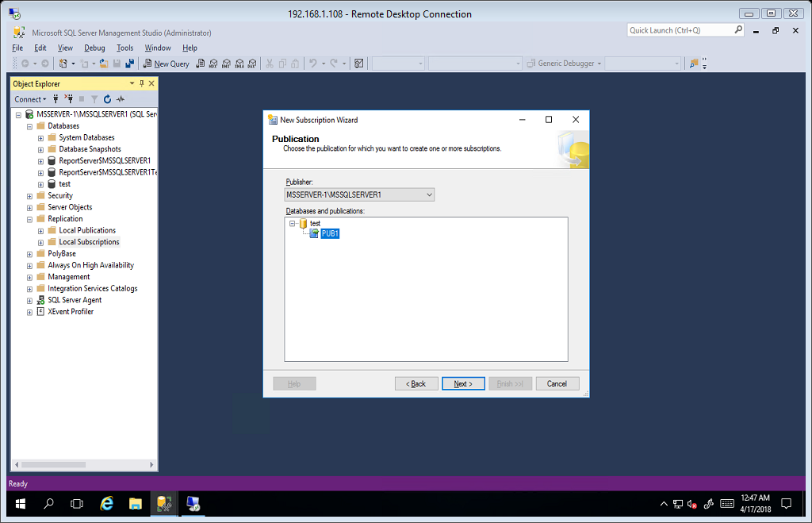

Distribution Agent Location. Select option 1, Run all agents at the Distributor. Click next.

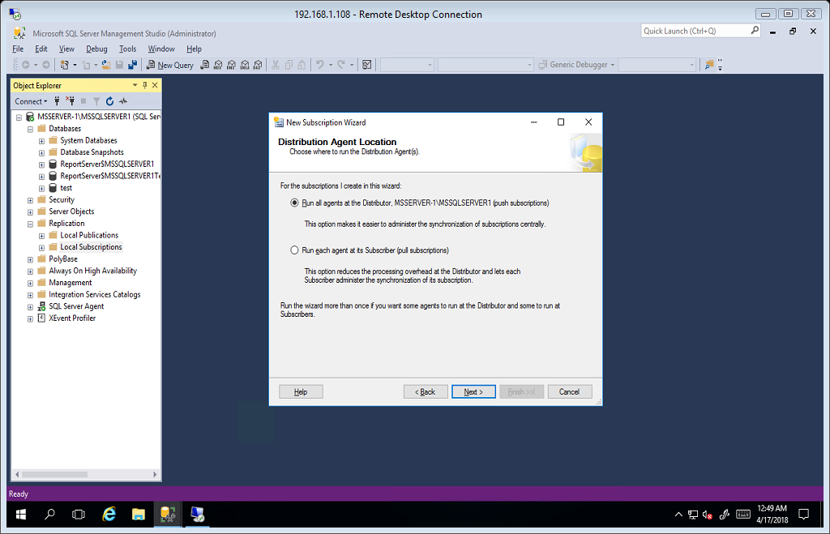

Subscriber. Click Add Subscriber to add subscriber and select add SQL Server Subscriber.

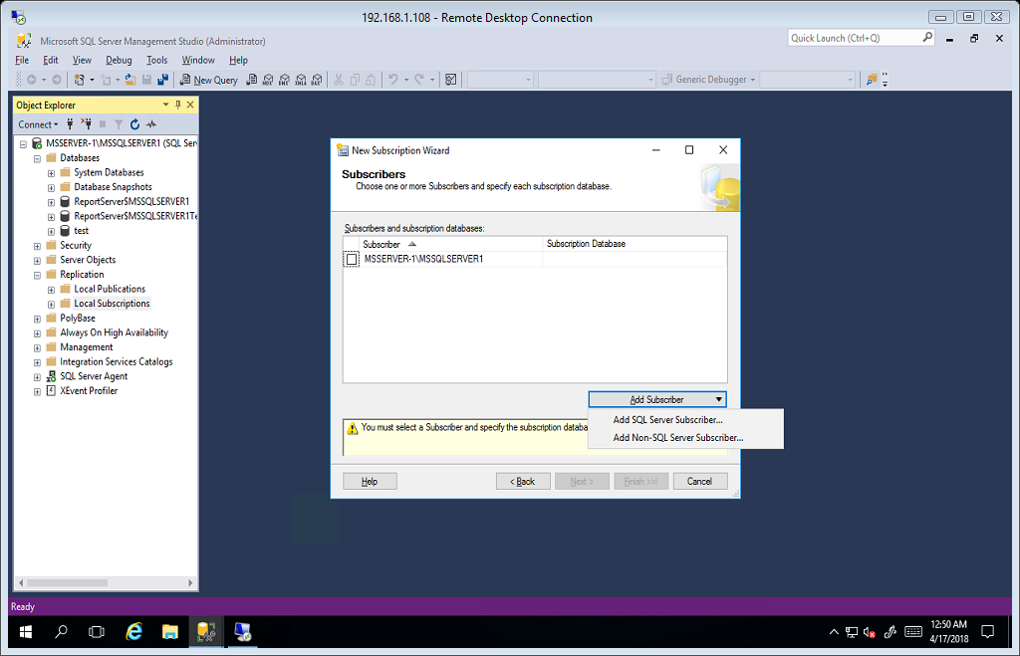

For this scenario our subscriber is MSSERVER-2\MSSQLSERVER2. And click connect.

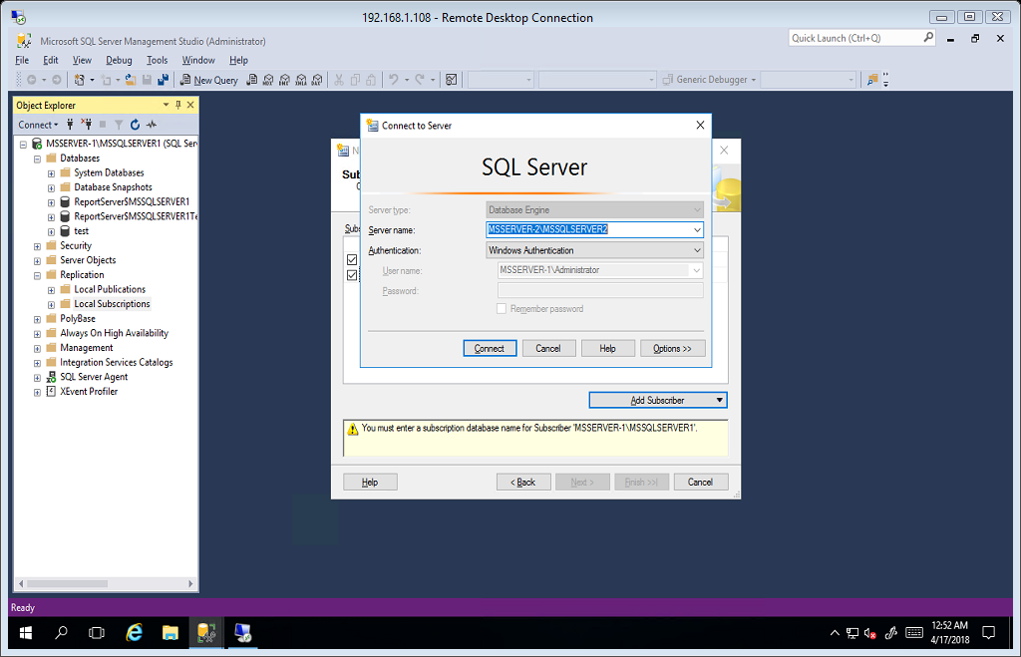

And in subscription database, select New database.

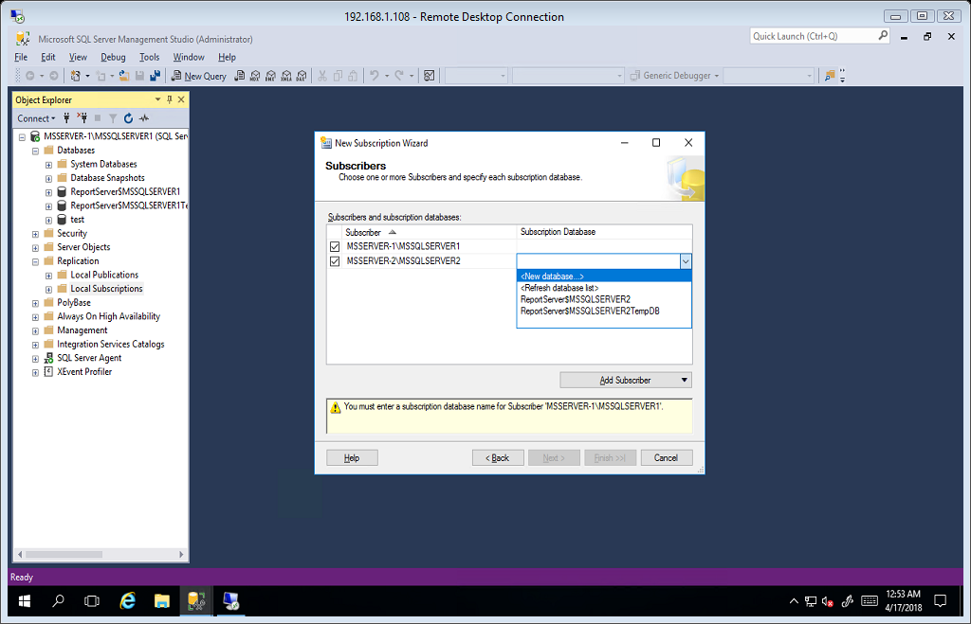

Enter Database Name. for this scenario we use test_sub. Click ok.

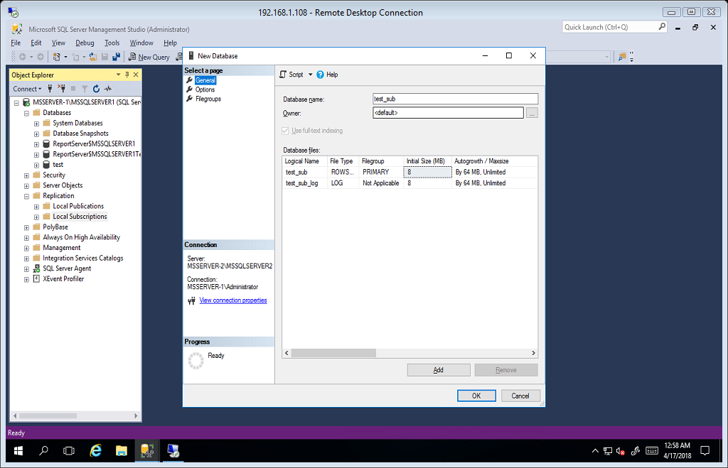

Subscription Server and Subscription Database are now ready. Click next to proceed.

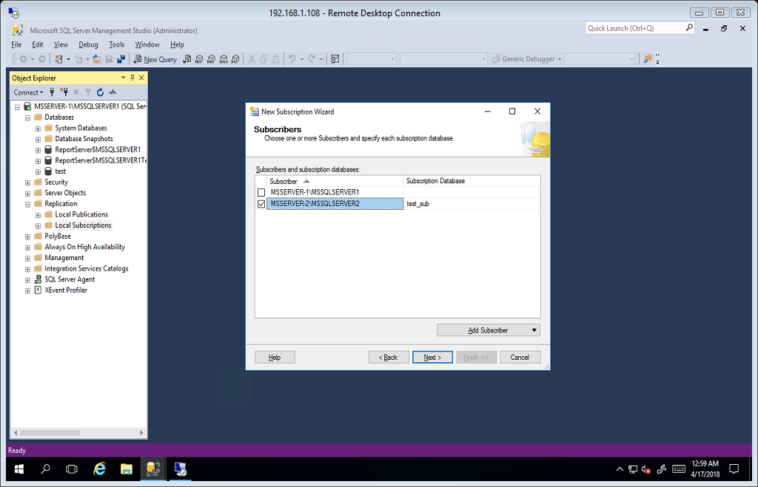

Distribution Agent Security. Click on the eclipse(…) to configure.

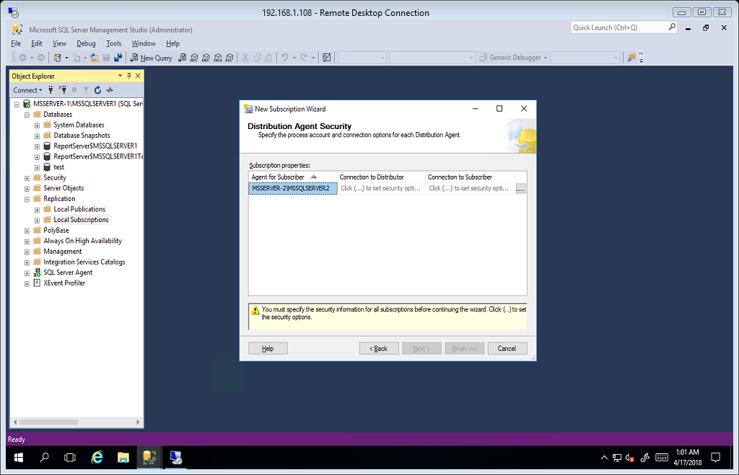

Select Run under SQL Server Agent service account(recommended).

In Connect the Distributor leave it by default.

In Connect to the Subscriber, select the option using the following SQL server login and enter the sa credentials. Click ok.

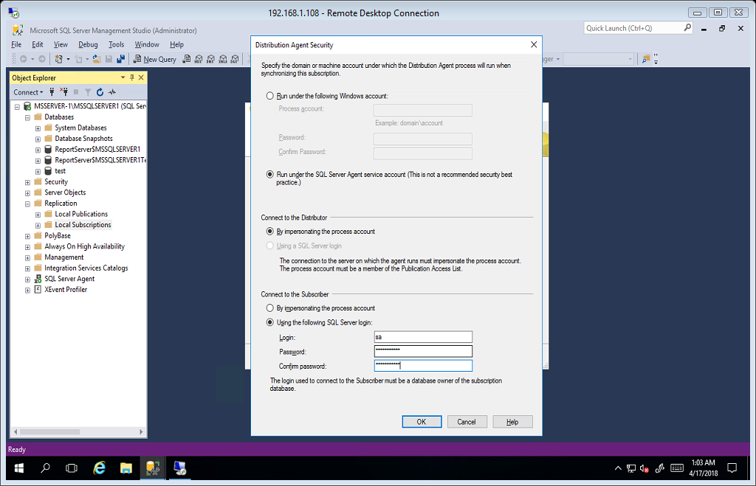

Click next to proceed.

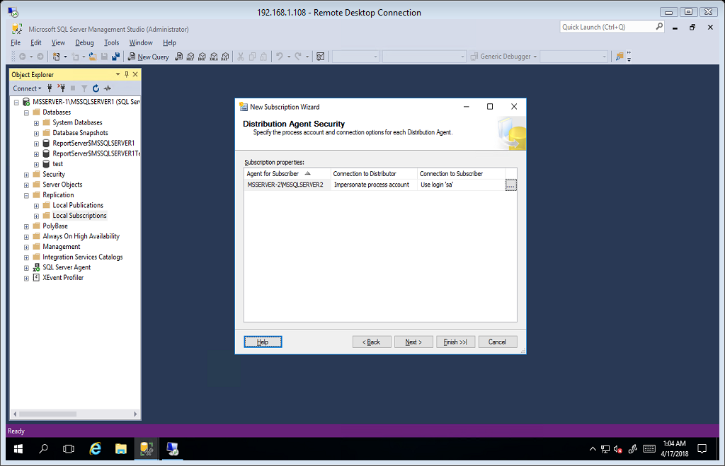

Synchronization Schedule, in Agent Schedule select Run Continuously and click next.

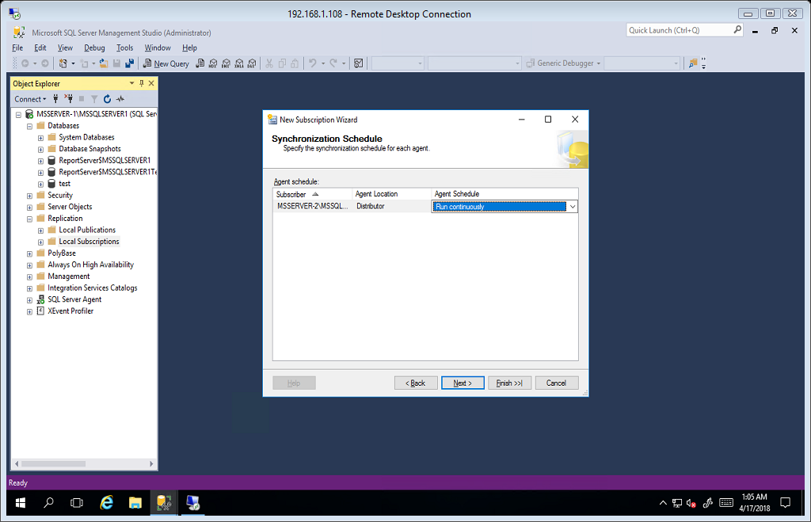

Initialize Subscriptions. By default click Next.

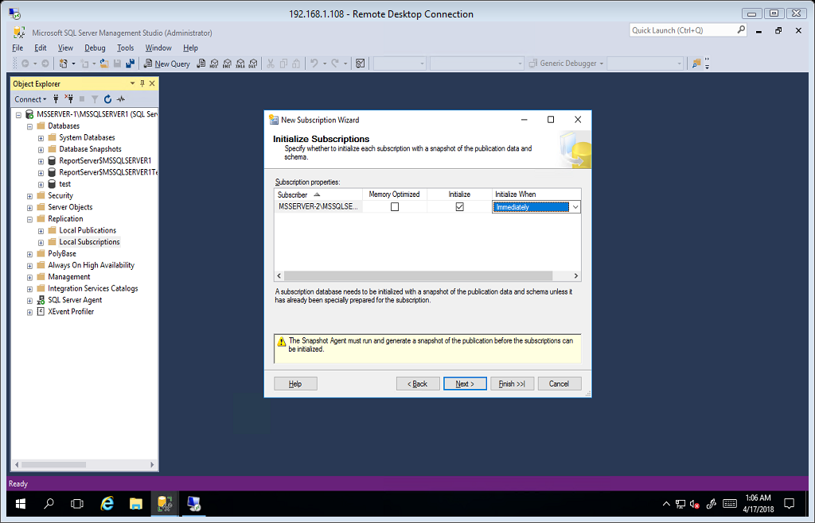

Wizard Actions. Select Create the Subscription and click next.

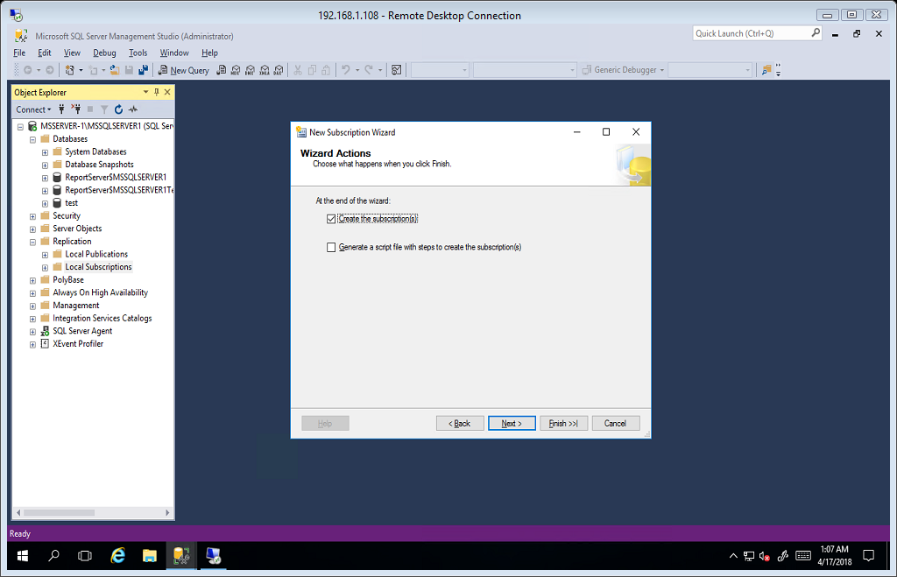

Click Finish to complete the wizard and click close.

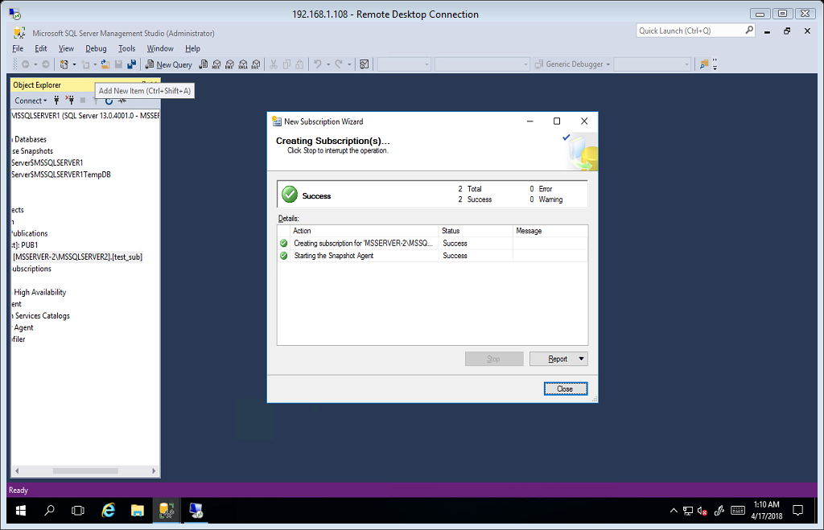

# VIEW SNAPSHOT AGENT IF RUNNING.

Under local subscriptions folder right click on the Publisher we created and select View Snapshot Agent Status.

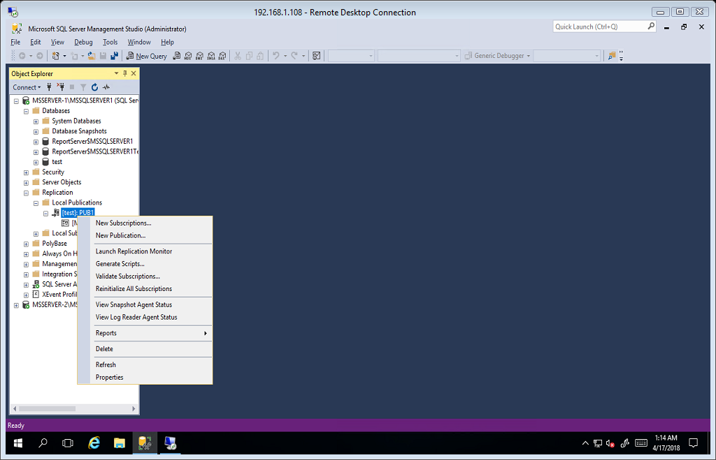

Access to the path is denied. We need to create permission for the Snapshot agent to access the snapshot folder.

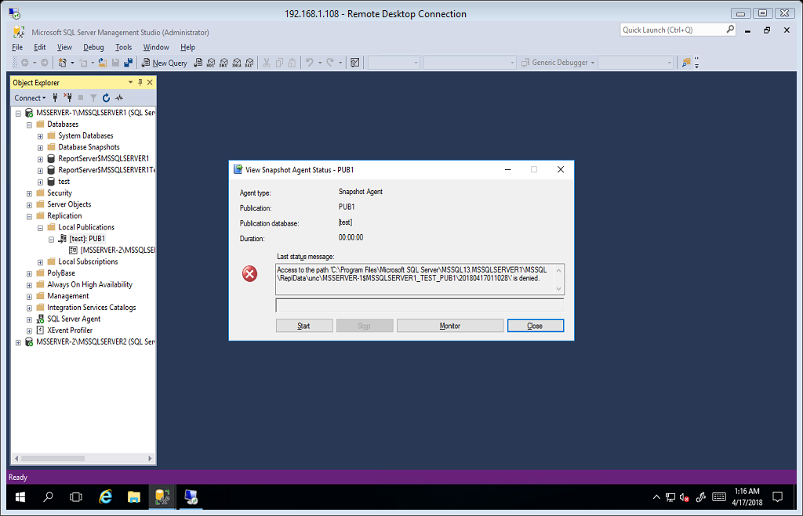

We need to identify the account of snapshot agent. Run the SQL Server 2016 configuration.

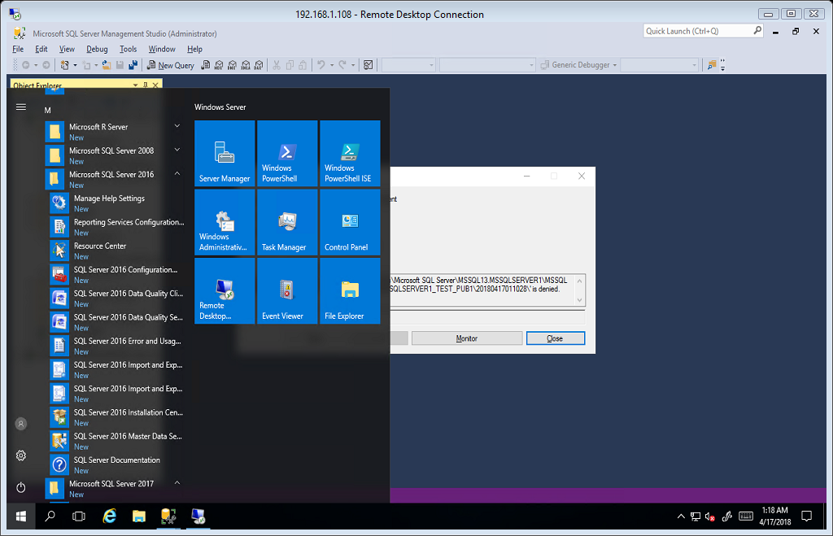

Click Sql Server Services and in the services running right click on Sql Server agent and select properties.

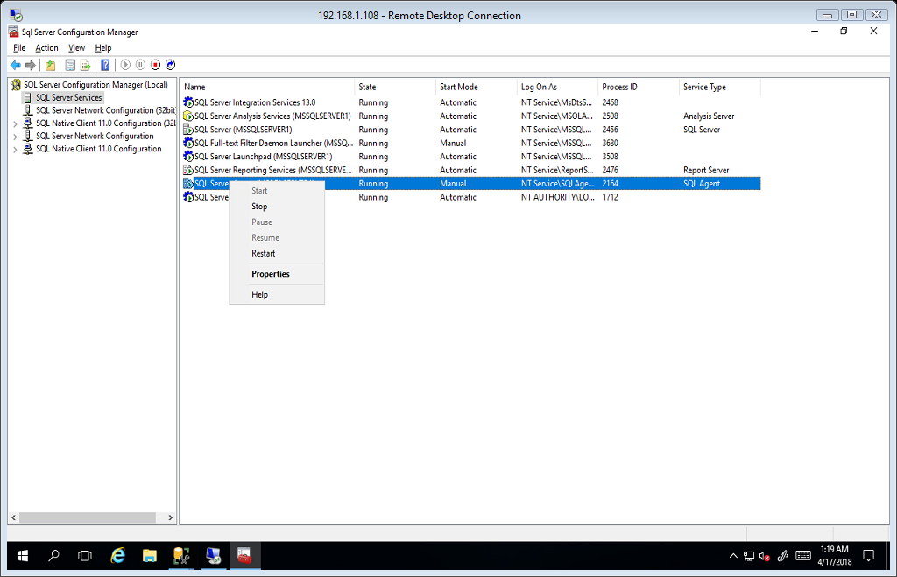

Copy the Account name.

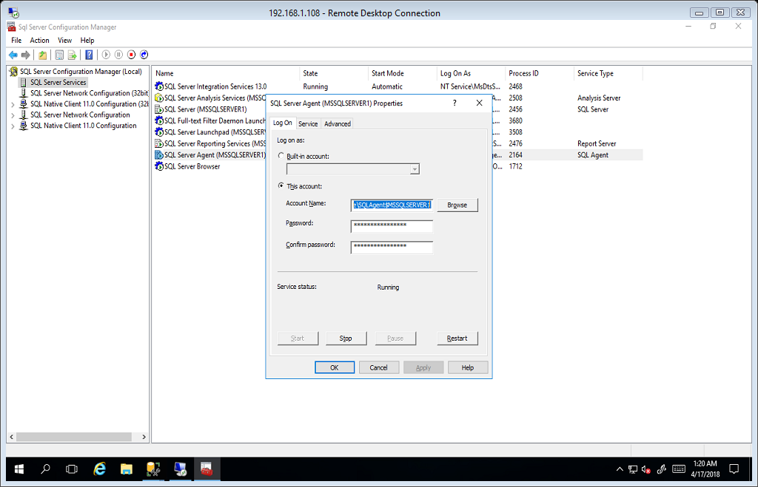

Now go to Snapshot Folder in C:\Program Files\Microsoft SQL Server\MSSQL13.MSSQLSERVER1\MSSQL

Right click on repldata folder and select properties.

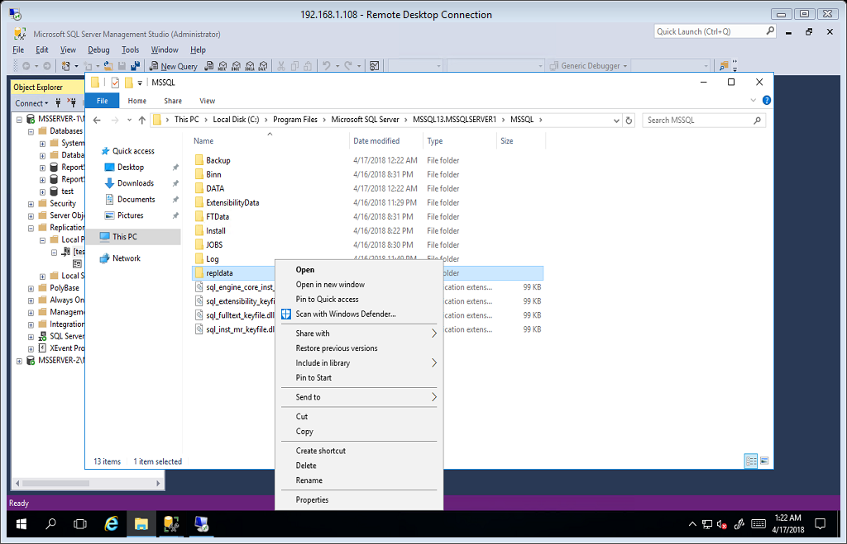

In sharing tab click Advanced Sharing Button.

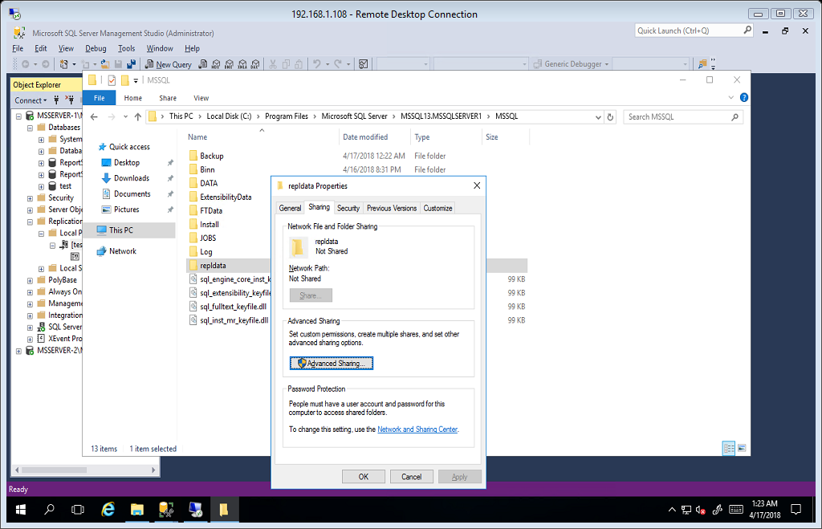

Select Share folder, and click the permissions button.

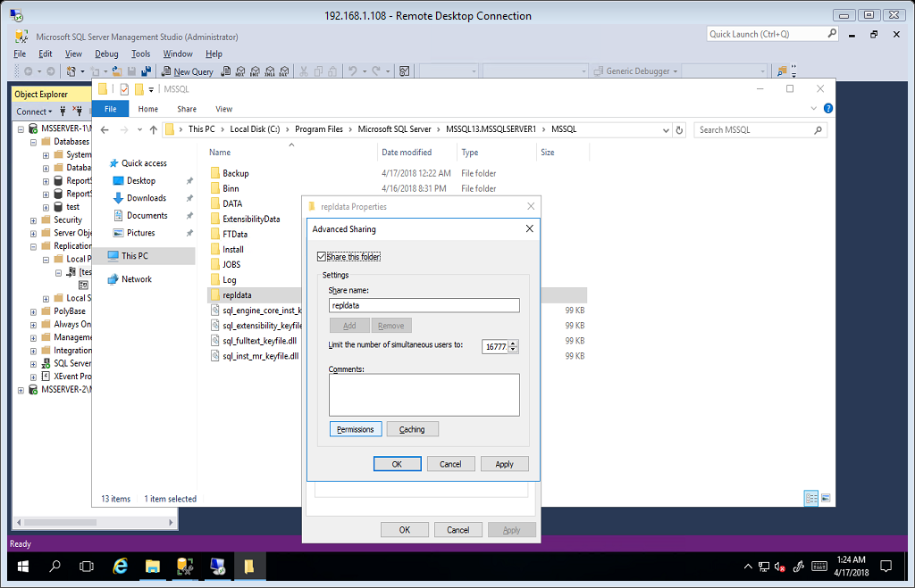

We need to add now the SQL Snapshot Agent Account on this folder. Click Add.

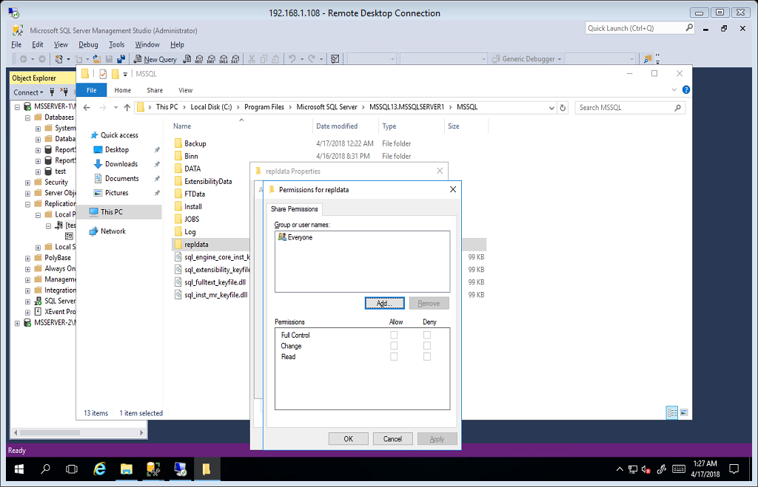

Paste the Snapshot agent account in name field and click check names and click ok

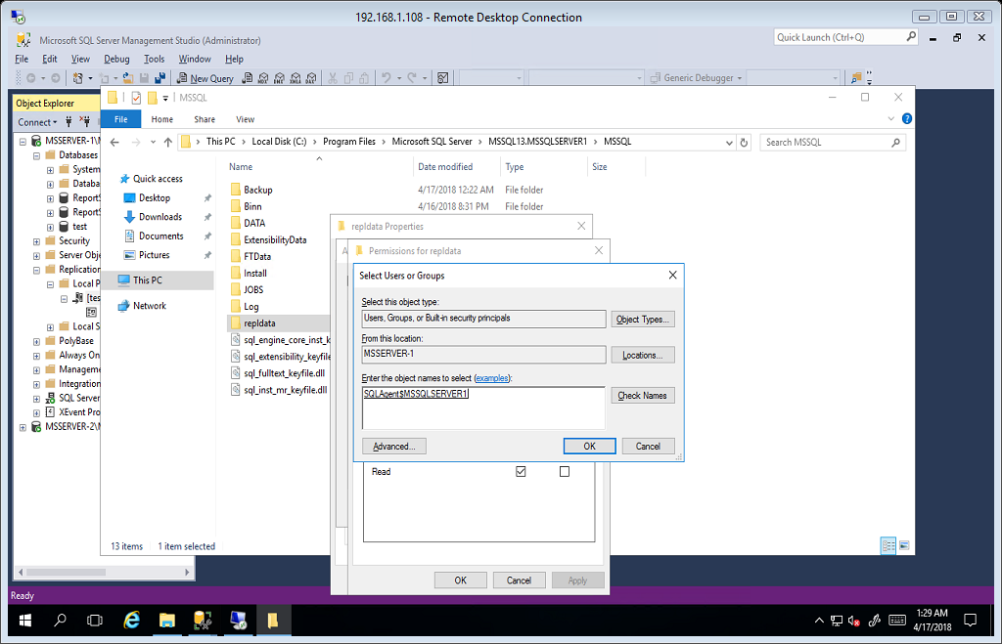

Give Full control permissions to the snapshot agent and click ok.

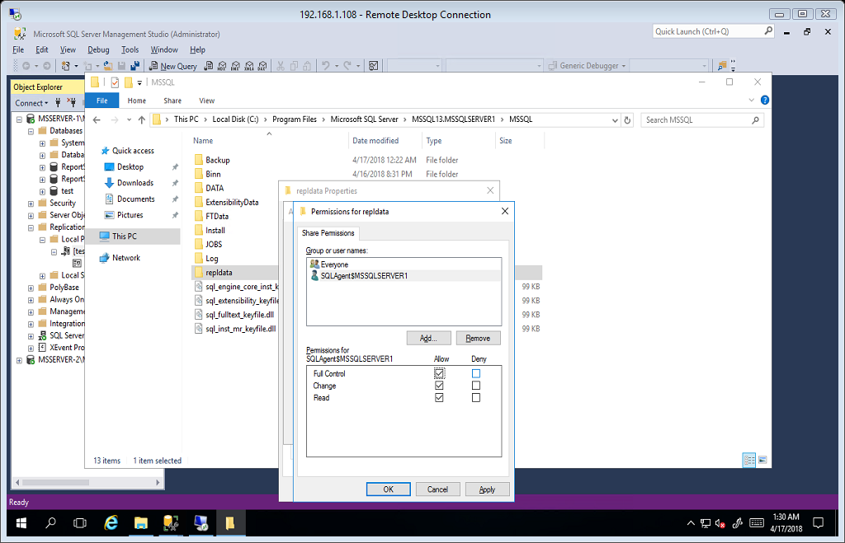

Right click again and select properties and go to security tab and click Edit button.

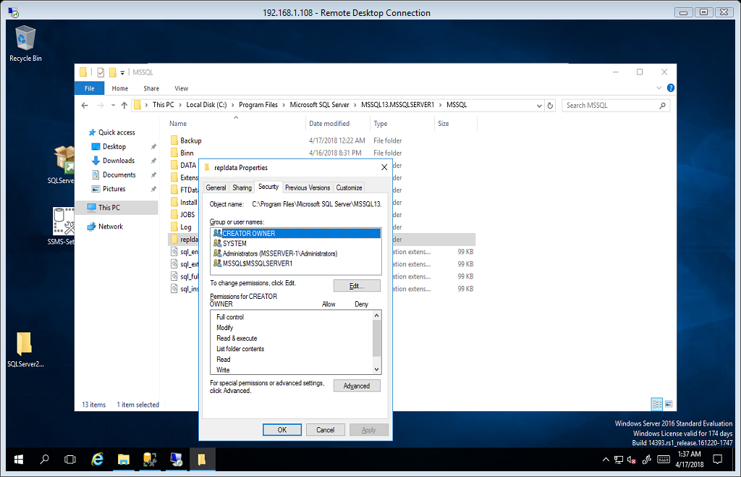

Click Add button to Add the Snapshot agent.

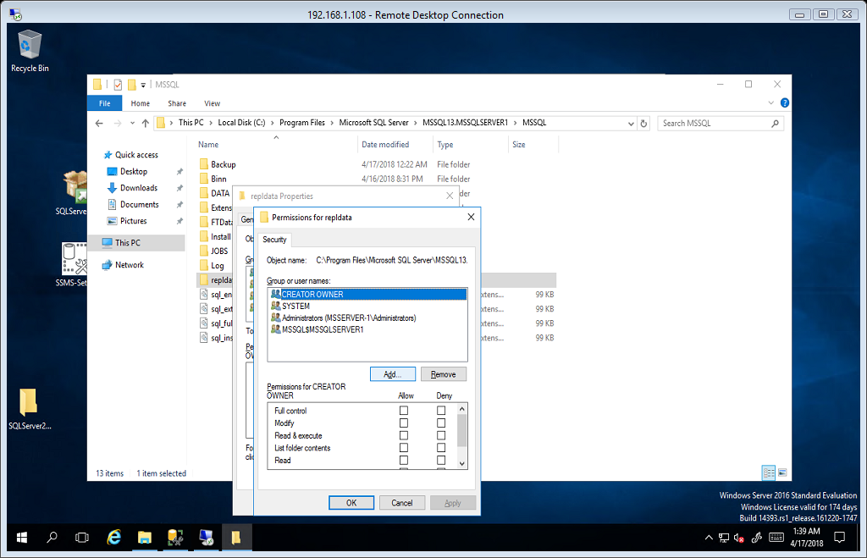

And enter the Snapshot Agent Account and click check named and click ok.

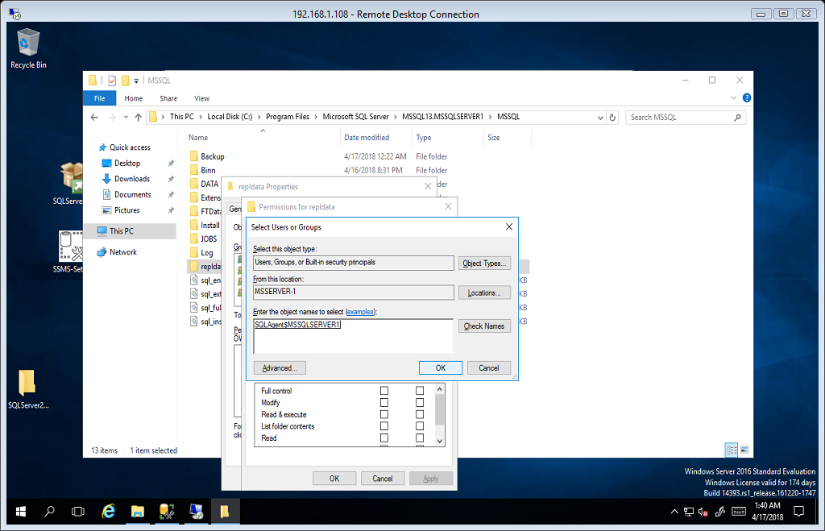

And give the full permissions for the snapshot agent and click Ok.

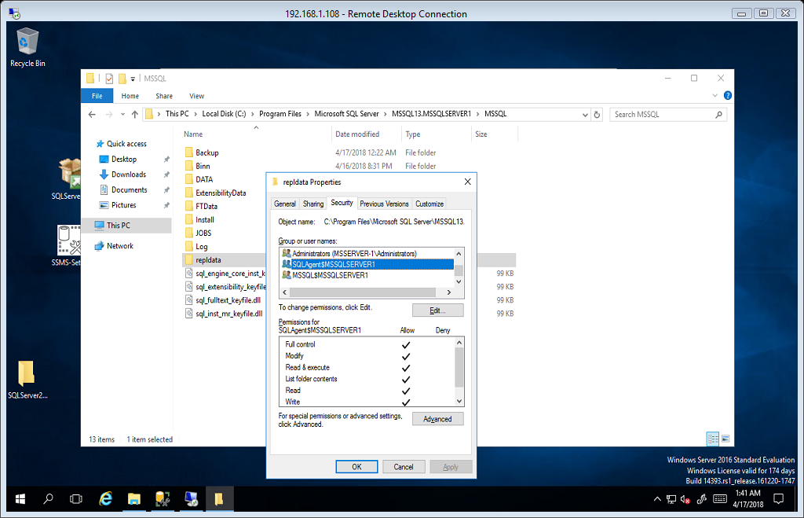

And Now check again the status of Snapshot Agent. Click start. If the check mark appear then our Replication is success.

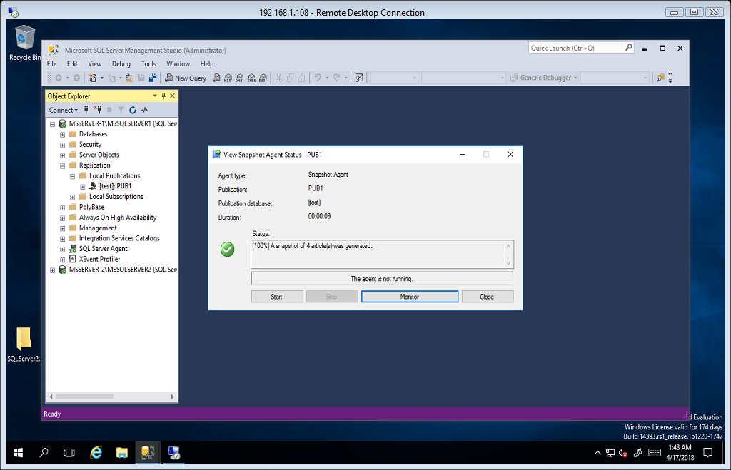

# Checking the replicated table on Subscriber Server. MSSERVER-2\MSSQLSERVER2

Check the Replicated Database if the table are replicated. Remember when we create a publisher we select 4 tables. This 4 table must reflect or replicated in Subscriber server.

